# Hands- on Assignments from Chapter 3 (page 97)

1. Graphical user interface, application

   Description automatically generatedCreate a new table containing the category code and description for the categories of books sold by JustLee Books. The table should be called **CATEGORY**, and the columns should be **CatCode** and **CatDesc**. The **CatCode** column should store a maximum of characters, and the **CatDesc** column should store a maximum of 10 characters.
2. Create a new table containing these four columns: **Emp#, Lastname, Firstname, and**

**Job_class**. The table name should be **EMPLOYEES**. The Job_class column should be able

to store character strings up to a maximum length of four, but the column values shouldn’t

be padded if the value has less than four characters. The **Emp#** column contains a numeric

ID and should allow a five-digit number. Use column sizes you consider suitable for the

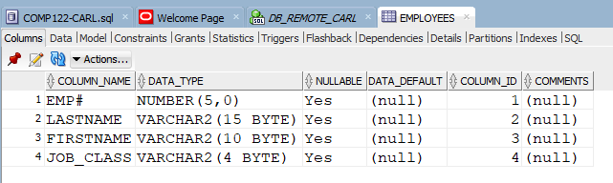Firstname and Lastname columns.

1. Add two columns to the **EMPLOYEES** table. One column, named **EmpDate**, contains the

date of employment for each employee, and its default value should be the system date.

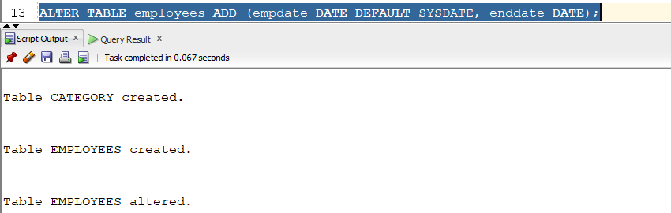The second column, named **EndDate**, contains employees’ date of termination.

1. Modify the **Job_class** column of the **EMPLOYEES** table so that it allows storing a maximum

width of two characters.

1. Text

   Description automatically generated with medium confidence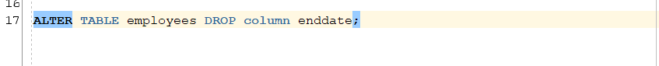Delete the **EndDate** column from the **EMPLOYEES** table.
2. Rename the **EMPLOYEES** table as **JL_EMPS**.

1. Create a new table containing these four columns from the existing **BOOKS** table: **ISBN,**

**Cost, Retail, and Category.** The name of the ISBN column should be **ID**, and the other

columns should keep their original names. Name the new table **BOOK_PRICING**.

1. Mark the Category column of the **BOOK_PRICING** table as unused. Verify that the column

is no longer available.

1. Truncate the **BOOK_PRICING** table, and then verify that the table still exists but no longer

contains any data.

1. Delete the **BOOK_PRICING** table permanently so that it isn’t moved to the recycle bin.

Delete the **JL_EMPS** table so that it can be restored. Restore the JL_EMPS table and

verify that it’s available again.

Note: When I dropped the table JL_EMPS, it was directly deleted and didn’t go through to the RECYCLEBIN,

I look for ways to enable the RECYCLEBIN but I need an administrative command to enable this. It doesn’t work instead so I just put here my input assuming the JL_EMPS table was dropped and in goes to RECYCLEBIN. The second screenshot attached assumed that the code works.